1. Define a table ‘Source’ in your dataset.

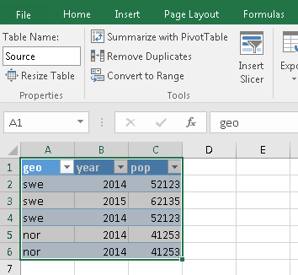

1. Go to Data > From Table > Go to the ‘Advance Editor’. Replace all content with the content of script_exector.m and change the script file location.

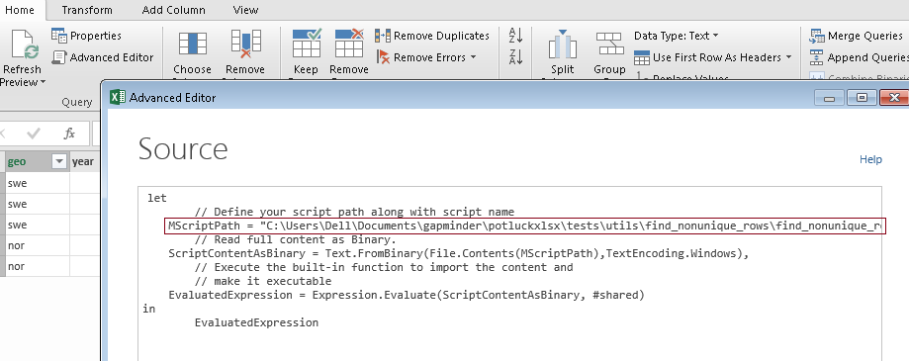

1. Press done. This will give you the non-unique rows.